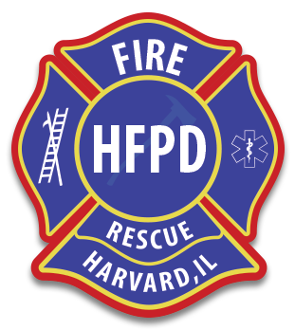

HARVARD FIRE PROTECTION DISTRICT 2021 MEETING DATES
The following is a list of dates and times of meeting for the Board of Trustees of the Harvard Fire Protection District.
January 12, 2021
February 9, 2021
March 9, 2021
April 13, 2021
May 11, 2021
June 8, 2021
July 13, 2021
August 10, 2021
September 14, 2021
October 12, 2021
November 9, 2021
December 14, 2021
All Board of Trustees meetings begin at 7:00 P.M. in the meeting room at 502 South Eastman Street in Harvard Illinois.
If you are sight or hearing impaired and would like a translator for the meeting, please contact the Fire Chief, 14 days in advance of the meeting by email at LKane@hfpd.org or by phone at 815-943-6927.

